

**UNITED STATES**

**ACADEMIC DECATHLON®**

**SPEECH GUIDELINES**

1. Guidelines for Judging Speech 2 - 4
   1. Teams of Judges
   2. Schedule
   3. Time Rules
   4. General Rules
   5. Procedure to Be Followed in Each Speech Room
   6. Judges
   7. Head Judge
   8. Final Reminders
2. Scripts for Speech Head Judge and Timer 5
3. Time Format and Room Setup 6
4. Speech Competition Rules and Guidelines 7 - 8
   1. Objectives
   2. Criteria for Prepared Speech
   3. Criteria for Impromptu Speech
   4. Speech Penalties
5. Descriptors for Prepared and Impromptu Speeches 9 - 10
6. Prepared Speech Rating Scale 11
7. Impromptu Speech Rating Scale 12
8. Online Speech Evaluation Form 13–16
9. Judge Training Survey Form 17

**GUIDELINES FOR JUDGING SPEECH**

Thank you for serving as a Speech Judge in this year’s National Academic Decathlon® speech event! **Each Decathlete will be giving a prepared speech and an impromptu speech.** Please read the following carefully and adhere to all procedural and timing guidelines. Enjoy the event!

## **Teams of Judges**

Each team of judges will consist of 2−3 speech judges. Each team of judges will be assigned to a specific room and will be evaluating one Decathlete at a time using the U.S. Academic Decathlon Speech Evaluation Form, which is an online Google form, to score the speeches. A link to this form will be shared with judges prior to the speech event. Judges will use an Internet-enabled device to complete the scoring. Devices will be provided, but if judges prefer to use their own cell phones, tablets, or laptops, they may do so. Each judge will evaluate the Decathlete *individually*—the judges will NOT collaborate on scoring, come to consensus, or discuss the scoring of the speeches. The scores of the speech judges will be averaged together to form one score for each Decathlete.

## **Schedule**

**Please be sure to time accurately for a fair competition and release** **Decathletes ON TIME**. Stopwatches or timers will be provided to time the two speeches (prepared and impromptu). Timers may use their cell phone as a timer. All Decathletes **must** receive the same amount of time for each speech.

## **Time Rules**

* Time speeches precisely
* Admit and dismiss Decathletes according to established schedule
* Each Decathlete is allotted approximately 8 minutes of time
  + 35 seconds for introductions/instructions
  + **3 ½ − 4 minutes for prepared speech**
  + 20 seconds to set up for impromptu speech
  + One-minute impromptu speech preparation
  + **1 ½ − 2 minutes for the impromptu speech**
  + 5 seconds to thank and dismiss the Decathlete
* Judges should have approximately 2 minutes to score the two speeches and prepare for the next Decathlete

**General Rules**

* NOTE CARDS may be used, but speech should not be read.
* GESTURES are acceptable, but PROPS are not allowed.
* Speech must be given STANDING unless a student is physically unable to do so.
* Speech must be researched, written, and delivered by the contestant.
* There are specific guidelines regarding the length of the two speeches. If either the prepared or impromptu speech is not within the proper time limit, a time violation is assessed.
* To avoid any possible perception of bias/favoritism, judges should NOT ask a Decathlete what school or area they are from. There is no penalty if a Decathlete reveals where they live or what school they attend.
* If a judge knows a Decathlete or has any other type of bias toward that Decathlete, the judge should disqualify themself for that round. The head judge should note this and inform the speech coordinator at the end of the event. If there are only two judges in the room, judges must score the Decathlete regardless of their knowledge of the Decathlete. Knowledge of a Decathlete should not influence judging of speech.
* Judges should not discuss the speeches. Each speech judge must score the Decathlete’s performance independently.
* Judges are not to applaud or provide any written or verbal praise or recommendations to a Decathlete’s speech.
* Speeches are not to be rank ordered with other speeches. That is, each prepared and/or impromptu speech is to be evaluated independently based on its own merits using the rubric provided via the Speech Evaluation Form.

**Procedure to Be Followed in Each Speech Room**

* Each speech session shall be approximately fifty minutes in length. Approximately five students will be assigned to each room per session. The five students will enter together at the start of the session and will not exit the speech room until the end of the session, after all five students have presented their speeches.
* The Head Judge welcomes the Decathletes to the room and asks all but the first scheduled student speaker to take their seats.
* Judges should have the Speech Evaluation Form open on their devices and have the first few fields of information (e.g., judge name, student ID#, etc.) filled in. The head judge will confirm the student’s ID number, and judges will double-check that they have entered it correctly on the scoring form.
* Head Judge will explain the procedures to Decathlete.
* Timer explains timing procedure and timing cards. Head Judge will signal Decathlete to START prepared speech *(“You may start”)*. Timer starts stopwatch or timer when Decathlete begins their speech, uses timing cards at appropriate times, and signals Decathlete to END prepared speech by holding the “0” time remaining card.
* Once the prepared speech has ended, the Head Judge will give instructions to the Decathlete about their impromptu speech. The Timer will only repeat the timing procedure if the student requests them to do so.
* Head Judge instructs the Decathlete to go to the Impromptu Table to prepare their impromptu speech.
* Timer starts timing impromptu preparation time (1 minute) once the Decathlete turns the impromptu card over. Impromptu cards/topics are rotated for each Decathlete. Timer will end the one-minute preparation time by announcing “time.” Judges may score the prepared speech during the impromptu prep time.
* Head Judge collects impromptu card from Decathlete and confirms speech topic Decathlete has selected.
* Head Judge will signal Decathlete to START impromptu speech *(“You may start”)*. Timer starts timing when the Decathlete begins their speech, uses timing cards at appropriate times, and signals Decathlete to END prepared speech.
* Head Judge will thank the Decathlete, collect any impromptu speech notecards and direct the Decathlete to take their seat.
* Timer will quietly indicate to the judges whether there are any timing penalties, and judges will mark the penalty section of the scoring form accordingly.
* Head Judge will then reset the Impromptu table and place a new Impromptu Card face down on the Impromptu table for the next Decathlete. Impromptu speech topics MUST be changed after each Decathlete.
* The above procedure will be repeated for each of the remaining five Decathletes until all students present in the speech room have given their speeches.
* After the fifth Decathlete (final student of the session) has presented both of their speeches, the head judge will thank that student and the group of students as a whole and will dismiss the group of students from the speech room. Head judge will remind students to exit QUIETLY out of consideration for students in nearby rooms.
* There will be a scheduled break between each five-student speech session. Judges should not leave the room at any time except during the scheduled breaks between the approximately fifty-minute speech sessions. It is imperative that judges return to their speech rooms with adequate time to prepare for the next session.

**Judges**

* Enter proper information at the top of the online Speech Evaluation Form prior to the start of the student’s speech. The student ID number is critical; check it carefully!
* After you complete the scoring of the prepared and impromptu speeches for each Decathlete, click the “Submit another response” button to bring up a new form for the next student. You should enter the information at the top of the form (your name, student ID#, etc.) for the next student.

**Head Judge**

* **For Decathletes who do not appear, head judge must keep a “No Show” list with the student names and ID#s of those students on the roster that did not arrive at their assigned time, and the head judge must give this list to the speech coordinator at the end of the event.**

**Final Reminders**

* BE AN OBJECTIVE JUDGE *– Your score should be your individual decision.*
* BE SURE to treat each Decathlete in the same manner. Maintain your objectivity throughout the day and HAVE FUN!

***Thank you for volunteering for this event. We appreciate your time!***

**SCRIPTS FOR SPEECH HEAD JUDGE AND TIMER**

**Head Judge’s instructions to Decathlete before prepared speech:**

**“You will be presenting your prepared speech. This speech should be no less than 3 ½ minutes and no more than 4 minutes. When the Timer holds up the “0” time remaining card, you must stop immediately or receive a time penalty. The Timer will now give instructions regarding timing and will demonstrate the timing cards.”**

*(Pause for Timer’s instructions.)*

**“You may start when you are ready.”**

*(Timer begins stopwatch once student begins their speech.)*

***Head Judge’s instructions to Decathlete before impromptu speech:***

***“You will now prepare and present your impromptu speech. The impromptu speech must be no less than 1 ½ minutes and no more than 2 minutes. The timer will be showing the same three timing cards. Would you like the timer to review the timing cards again?”***

*(If student requests the timing instructions for the impromptu, pause for Timer’s instructions; otherwise, proceed.)*

***“A topic card with 3 impromptu topics is face down on that table*** *(gesture toward table****). After I instruct you to begin preparing your impromptu, you should turn over the topic card. You will have 1 minute to choose a topic and prepare your speech. There are notecards and pencils if you wish to use them.”***

***“You may begin preparing your impromptu speech.”***

*(Wait one minute until Timer calls time)*

***“Please hand me the topic card and indicate the topic you have chosen.”***

*(Pause while student indicates topic.)*

***“You may now begin your impromptu speech.”***

*(Timer begins stopwatch once student begins their speech.)*

**Timer’s instructions to Decathlete before prepared speech:**

***Remember: A prepared speech is “in time” if you speak between 3 ½ and 4 minutes. After you have spoken for three minutes, I will hold up the 1-minute card,*** *(show the student the card)* ***meaning you have 1 minute left to speak. After you have spoken for 3 ½ minutes, I will hold up the 30-second card,*** *(show the student the card)* ***meaning you have spoken 3 ½ minutes and still have 30 seconds left if you need them. After you have spoken for 4 minutes, I will hold up the “0” card,*** *(show the student the card)* ***meaning time is up******. I will not say “stop,” but you have no grace period and will be penalized if you continue.***

**Timer’s instructions to Decathlete before impromptu speech:**

***Remember: An impromptu speech is “in time” if you speak between 1½ and 2 minutes. After you have spoken for one minute, I will hold up the 1-minute card,*** *(show the student the card)* ***meaning you have 1 minute left to speak. After you have spoken for 1 ½ minutes, I will hold up the 30-second card,*** *(show the student the card)* ***meaning you have spoken 1 ½ minutes and still have 30 seconds left if you need them. After you have spoken for 2 minutes, I will hold up the “0” card,*** *(show the student the card)* ***meaning time is up. I will not say “stop,” but you have no grace period and will be penalized if you continue.*** *(As soon as the student turns over the impromptu card, begin timing the one-minute prep time. After one minute has elapsed, announce: “Time.”)*

TIME FORMAT AND ROOM SETUP

**REVIEW USAD SPEECH JUDGE SCHEDULE.**

**To be presented during the Speech Judge Orientation.**

**TIME FORMAT**

*Time allotted each Decathlete*

Time for introductions and review of procedures (script) 35 seconds

Prepared Speech 4 minutes

Transition to and from Impromptu table 20 seconds

Select & Prepare Impromptu 1 minute

Impromptu Speech 2 minutes

Thank you 5 seconds

Complete Scoring of Speeches 2 minutes

**Total Time** 10 minutes

# SAMPLE ROOM SETUP

Competing Decathlete

3 Judges + 1 Timer

 Impromptu Prep Table

Additional Decathletes

SPEECH COMPETITION RULES AND GUIDELINES

Objectives

* To assess the Decathlete’s ability to present a speech prepared in advance in accordance with specific written criteria.
* To assess the Decathlete’s ability to make an impromptu speech.

Criteria and Rules and Regulations for Prepared Speech

* **Content**
  + There is no required speech topic.
  + Speeches must be the original work of the Decathlete and must not have been used in any previous competition other than the Academic Decathlon® for this year.
* **Time**
  + Length is three and one-half (3 ½) to four (4) minutes. The Timer (timekeeper) gives signals when one (1) minute remains; again when thirty (30) seconds remains; and when no (0) time remains.
  + **If the speech is not within the proper time limit (i.e., 3:30 to 4:00), a time violation penalty is assessed.**
* **Delivery**
  + Overreliance on note cards, where the Decathlete actually reads some parts of the speech, represents a poorly prepared speech and should not be scored above the *Fair* range in *Speech Development* and other categories.
  + Glancing at note cards as an occasional guide, especially if it does not detract from the presentation, should not be penalized in any way.
  + Gestures are acceptable, but props (including uniforms and costumes) are not permitted.
  + The Decathlete must stand while delivering their speech if they are physically able to do so.

Criteria for Impromptu Speech

* **Content**
  + The Decathlete is given a card with three speech topics written on it. The Decathlete picks one of the three topics and speaks on that topic.
* **Time**
  + The impromptu speech is delivered immediately following the prepared speech.
  + The Decathlete has one minute to select and prepare the topic selection once the Impromptu Card has been turned over by the Decathlete. The Decathlete must remain at the Impromptu Table while preparing the impromptu speech. Note cards and pencils will be provided on the Impromptu Table. The Decathlete may not leave the room during the speech preparation time.
  + The length of the speech is one and one-half (1.5) to two (2) minutes. The timekeeper gives signals when one (1) minute remains; again when thirty (30) seconds remains; and when no (0) time.
  + **If the speech is not within the proper time limit (i.e., 1:30 to 2:00), a time violation penalty is assessed.**
* **Delivery**
  + Same guidelines as the prepared speech.
* **Evaluation**
  + The Speech Evaluation Form (the online Google form) shows specific items for the Decathlete’s evaluation.

**Speech Penalties**

* There is no penalty for disclosing a Decathlete’s school name or location.
* After the Decathlete has completed both the prepared and the impromptu speeches, the Timer will quietly indicate to the judges whether a timing penalty must be assessed. The Timer is the final arbiter in the case of time violations. All Speech Evaluation Forms for a student must reflect the same penalty from all judges.
* Decathletes should be familiar with the Speech Rules and Guidelines as outlined in the USAD Study Guide.

# **DESCRIPTORS FOR PREPARED AND IMPROMPTU SPEECHES**

**Guidelines for Judging a Prepared Speech:**

**Speech Development** (the way the speaker puts ideas together, so the audience can understand them)

* Organization
  + Does the speech flow from one idea to the next while staying on the topic?
* Body
  + Does the body explain or expand on the topic?
* Opening/Closing
  + Does the opening introduce the topic of the speech?
  + Does the conclusion bring the topic to a definite close?

**Effectiveness** (measures the reception of how the speech comes across to the audience)

* Achievement of purpose
  + Did the speech complete a description, point of view, or explanation completely?
* Interest
  + Did the decathlete seem interested in their speech?
  + Students who watch the clock or look around demonstrate a lack of interest.
* Reception
  + Was the judge interested in listening to the speech regardless of topic?
  + The judge may not agree with the topic/position but is still engaged in the speech.

**Correctness** (the proper use of grammar and correct pronunciation)

* Grammar
  + Did all sentences have proper breaks? Did the student use “run-on” sentences?
* Pronunciation
  + Were all words pronounced correctly?
* Word selection
  + Does the decathlete use language appropriate for the high school level?
  + For example: Using “received a letter” instead of “got a letter.”

**Appropriateness** (refers to the choice of words in relation to the purpose of the speech)

* Word selection and style appropriate to audience
  + Is the speech respectful, non-derogatory, and free of offensive language?
  + Use of slang is acceptable if the speech is enhanced by the use.
  + The speech should not be too conversational (e.g., with questions directed at judges).

**Speech Value** (justifies the act of speaking and responsibility of speaker to say something meaningful)

* Ideas
  + Does the speech sound like the student’s own words?
  + Paraphrasing or quotes are allowed if credit is given to original author.
  + Plagiarism is unacceptable.
  + Does the speech sound like the student did their own research or shared their own experience?
* Logic
  + Do the ideas presented fit the topic?
  + For example: introduces topic on sports, but the main idea is about healthy dieting.
* Originality
  + Is the topic unique or presented in an original way?

**Voice** (the sound that carries the message)

* Flexibility
  + Does the decathlete present the speech in a way that is interesting; with differentiating tones correlating with emotions when appropriate?
* Volume
  + Does the decathlete raise and lower their voice in the appropriate places?
  + Is the speech at a level the judges can hear?
* Variety
  + Does the student speed up and slow down when it is appropriate?
  + Speeches should not be fast all the way through.

**Non-Verbal** (is the physical presence of the speaker)

* Appearance
  + Is the decathlete dressed in appropriate attire?
  + Props and costumes are not permitted.
* Movement
  + Does the decathlete have natural and appropriate gestures and movements?
  + The decathlete must stand while delivering their speech.
* Assurance
  + Does the decathlete make eye contact with the judges?
  + Does the decathlete sound prepared?
* Notecards
  + Decathlete can glance at notecards as an occasional guide, especially if it does not detract from the delivered speech.

**Guidelines for Judging an Impromptu Speech** (s*ame as the prepared speech but separated into these categories and subcategories):*

**Content** (reflects the quality of ideas expressed and how the ideas are organized)

* Originality (speech value)
* Ideas (speech value)
* Organization (speech development)

**Delivery** (the way the speaker presents the ideas)

* Movement/gesture
* Body language (movement)
* Voice (flexibility, volume, variety)

**Overall Effectiveness** (how well the speaker achieved the purpose of the speech)

* Achievement of purpose (effectiveness)
* Verbal communication (correctness and appropriateness)

Rating Scale:

Excellent……………….10-9

Very Good………………8-7

Good…………………….6-5

Fair………………………4-3

Poor……………………..2-0

* Non-verbal communication (movement and assurance)

**Speech Penalty/Timing Violation**

* Fill in only one bubble after **BOTH** speeches are complete.
* If the decathlete is under **OR** over the time allotted, the Timer will inform the judges of this. Judges will mark their Speech Evaluation Form accordingly (by clicking one of the following four bubbles: “Prepared,” “Impromptu,” “Neither,” or “Both.”)
* If there are no penalties, judges must click the “Neither” bubble.
* All judges must mark the same bubble for the same decathlete.

**PREPARED SPEECH RATING SCALE**

|  |  |  |  |  |  |
| --- | --- | --- | --- | --- | --- |
|  | **Excellent (10 - 9)** | **Very Good (8 - 7)** | **Good (6 - 5)** | **Fair (4 - 3)** | **Poor (2 - 0)** |
| **Speech Development**   * **Organization** * **Body** * **Opening & Closing** | **Excellent** **structure** with an intro that captures your attention and moves forward toward a significant conclusion. Includes **excellent** **examples**, illustrations, facts and figures that are delivered with such smoothness that blend into the framework of the speech to present the audience with a unified whole. | **Very good** **structure** with an intro that captures your attention and moves forward toward a good conclusion. Includes **very good** examples, illustrations, facts and figures that are delivered so that they generally blend into the framework of the speech. | **Good** **structure** with an introduction and generally moves forward toward a conclusion. Includes **some** **good** **examples**, illustrations, facts, and figures. | **Some structure** but hard to follow at times. Includes **some** **examples**, illustrations, facts, and figures but they may have difficulty relating them to the topic being presented. Speaker read a portion of their speech. | **Poor or no structure** and is hard to follow. The speech includes **poor or no examples**, illustrations, facts, and figures. Speaker relied on notecards for a major portion or all of their speech. |
| **Effectiveness**   * **Achievement of Purpose** * **Interest** * **Reception** | **Excellent** job communicating a clear and easy to identify purpose. Elements of the speech related directly to the purpose. E**xcellent** job holding the attention of the audience throughout the entire speech. | **Very good** job of communicating a purpose that was clear. Elements of the speech related directly to the purpose. V**ery good** job holding the attention of the audience. | **Good** job of communicating a purpose. Elements of the speech generally related to the purpose. G**ood** job holding the attention of the audience for most of the speech. | Attempts to communicate a purpose but may not be clear. Not all elements of the speech relate to an overall purpose. **Fair** job of holding the attention of the audience for only some of the speech. | Does not communicate a purpose. Elements of the speech seemed random without a focus or purpose. **Poor** job of holding the attention of the audience. |
| **Correctness**   * **Grammar** * **Pronunciation** * **Word Selection** | **Excellent** use of language and word selection which ensures that attention is directed towards what the speaker says, not how it is said. **Excellent** use of grammar and correct pronunciation. | **Very good** use of language and word selection which ensures that attention is directed towards what the speaker says, not how it is said. **Very good** use of grammar and correct pronunciation. | **Good** use of language and word selection. The speaker in general has a good use of grammar and correct pronunciation but may make a few mistakes. | **Fair** use of language and makes some mistakes in word selection. The speaker makes quite a few mistakes in grammar and pronunciation. | **Poor** use of language and makes frequent mistakes in word selection. The speaker makes frequent mistakes in grammar and pronunciation. |
| **Appropriateness**   * **Word selection and style appropriate to the audience** | **Excellent** topic choice for the audience and the speaker uses words and a style that fits the nature of the speech. | **Very good** topic choice for the audience and the speaker uses words and a style that fits the nature of the speech. | **Good** topic choice for the audience. Speaker generally uses words and a style that fits the nature of the speech; however, some content may not be appropriate. | **Fair** topic choice and may not be totally appropriate. Words and style may be inappropriate or speaker breaks one of the USAD rules (the speech is sung, etc.). | **Poor** topic choice and may be offensive or not be totally appropriate. Words and style are very inappropriate or speaker breaks one of the USAD rules (the speech is sung, etc.). |
| **Speech Value**   * **Ideas** * **Logic** * **Originality** | **Excellent** job presenting meaningful and original ideas. Excellent logical ideas that contribute to the thinking of the audience. (Although this does not preclude a humorous presentation of theme.) | **Very good** job presenting meaningful and original ideas. Good logical ideas that make a contribution to the thinking of the audience. | **Good** job presenting generally meaningful and original ideas. Generally have good logical ideas that make some contribution to the thinking of the audience. | **Fair** job presenting some meaningful ideas but may not be very unique. Has some logical ideas that make a contribution to the thinking of the audience. | **Poor** job of presenting meaningful ideas. Poor job presenting logical ideas that make any contribution to the thinking of the audience. |
| **Voice**   * **Flexibility** * **Volume** * **Variety** | **Excellent** use of voice…flexible moving from one pitch to another for **excellent** emphasis of ideas and information being presented. Voice could be clearly heard and words easily understood. | **Very good** use of voice…flexible moving from one pitch to another for emphasis. Voice could be clearly heard and words easily understood. | **Good** use of voice…some flexibility moving from one pitch to another for emphasis. Voice could generally be heard and words were mostly understood. | **Fair** use of voice that showed little flexibility only occasionally moving from one pitch to another. Voice might not always be heard and words may not be understood. | **Poor** use of voice that showed no flexibility and was generally monotone. Voice might not always be heard and words may not be understood. |
| **Non-Verbal**   * **Appearance** * **Movement** * **Assurance** | **Excellent** job using appearance to reinforce the speech, whether profound, sad, humorous, or instructional. Body language and movement supported points through use of gestures, expressions, and body positioning. | **Very good** job using appearance to reinforce the speech, whether profound, sad, humorous, or instructional. Body language and movement supported points through use of gestures, expressions, and positioning. | **Good** job using appearance to reinforce the speech. **Some** body language used to support points through use of gestures, expressions, and body positioning. | **Fair** job using appearance to reinforce the speech. **Little** body language used and when used may have been occasionally distracting to what the speaker was saying. | **Poor** job using appearance to reinforce the speech. **Little or no** body language used and when used may have been very distracting to what the speaker was saying. |

**IMPROMPTU SPEECH RATING SCALE**

|  |  |  |  |  |  |
| --- | --- | --- | --- | --- | --- |
|  | **Excellent (10 – 9)** | **Very Good (8 – 7)** | **Good (6 – 5)** | **Fair (4 – 3)** | **Poor (2 – 0)** |
| **Content**   * **Originality** * **Ideas** * **Organization** | **Excellent** job presenting meaningful, creative, insightful, and original ideas. **Excellent** **structure** with an intro that captures your attention and moves forward toward a significant conclusion. Includes **excellent** **examples** that blend into the framework of the speech to present the audience with a unified whole. | **Very good** job presenting meaningful, creative, insightful, and original ideas. **Very good** **structure** with an intro that captures your attention and moves forward toward a good conclusion. Includes **very good** examples that are delivered so that they generally blend into the framework of the speech. | **Good** job presenting generally meaningful, creative, insightful, and original ideas. **Good** **structure** with an introduction and generally moves forward toward a conclusion. Includes **some** **good** **examples**. | **Fair** job presenting some meaningful and insightful ideas but may not be very creative or unique. **Some structure** but hard to follow at times. Includes **some** **examples**, but they may have difficulty relating them to the topic being presented. Speaker had some distracting pauses. Speaker repeated a few ideas or examples to fill time. | **Poor** job of presenting meaningful ideas. **Poor or no structure** and is hard to follow. The speech includes **poor or no examples**. Speaker relied on notecards for a major portion or all of their speech. . Speaker had extensive distracting pauses. Speaker repeated multiple ideas or examples to fill time. |
| **Delivery**   * **Expressiveness** * **Body language, movement, gesture** * **Assurance** * **Voice—flexibility, volume, variety** | **Excellent** job using appearance to reinforce the speech. Body language, facial expressions, gestures support points. Demeanor consistently indicates confidence and engagement with audience and topic. **Excellent** use of voice…flexible moving from one pitch to another for **excellent** emphasis of ideas and information being presented. Voice could be clearly heard, and words easily understood. | **Very good** job using appearance to reinforce the speech. Body language, facial expressions, gestures support points. Demeanor generally indicates confidence and engagement with audience and topic. **Very good** use of voice…flexible moving from one pitch to another for emphasis. Voice could be clearly heard, and words easily understood. | **Good** job using appearance to reinforce the speech. Body language, facial expressions, gestures support **some** points. Demeanor **sometimes** indicates confidence and engagement with audience and topic. **Good** use of voice…some flexibility moving from one pitch to another for emphasis. Voice could generally be heard, and words were mostly understood. | **Fair** job using appearance to reinforce the speech. Body language, facial expressions, gestures **rarely** used to support points and/or appear forced or are distracting. Demeanor **rarely** indicates confidence and engagement with audience and topic. **Fair** use of voice that showed little flexibility only occasionally moving from one pitch to another. Voice might not always be heard, and words may not be understood. | **Poor** job using appearance to reinforce the speech. Body language, facial expressions, gestures **are not used** to effectively support points and/or appear forced or are distracting. Demeanor does not indicate confidence and engagement with audience and topic. **Poor** use of voice that showed no flexibility and was generally monotone. Voice might not always be heard, and words may not be understood. |
| **Overall Effectiveness**   * **Achievement of Purpose** * **Verbal Communication** * **Nonverbal Communication** | **Excellent** job communicating a clear and easy to identify purpose. Elements of the speech related directly to the purpose. **Excellent** job holding the attention of the audience throughout the entire speech. **Excellent** use of language and word selection. **Excellent** job using appearance to reinforce the speech. Facial expressions support points. Demeanor consistently indicates confidence and engagement with audience and topic. | **Very good** job of communicating a purpose that was clear. Elements of the speech related directly to the purpose. **Very good** job holding the attention of the audience. **Very good** job using appearance to reinforce the speech. Facial expressions support points. Demeanor generally indicates confidence and engagement with audience and topic. | **Good** job of communicating a purpose. Elements of the speech generally related to the purpose. **Good** job holding the attention of the audience for most of the speech. **Good** job using appearance to reinforce the speech. Facial expressions support **some** points. Demeanor **sometimes** indicates confidence and engagement with audience and topic. | Attempts to communicate a purpose but may not be clear. Not all elements of the speech relate to an overall purpose. **Fair** job of holding the attention of the audience for only some of the speech. **Fair** job using appearance to reinforce the speech. Facial expressions **rarely** used to support points and/or appear forced or are distracting. Demeanor **rarely** indicates confidence and engagement with audience and topic. | Does not communicate a purpose. Elements of the speech seemed random without a focus or purpose. **Poor** job of holding the attention of the audience. **Poor** job using appearance to reinforce the speech. Facial expressions **are not used** to effectively support points and/or appear forced or are distracting. Demeanor does not indicate confidence and engagement with audience and topic. |

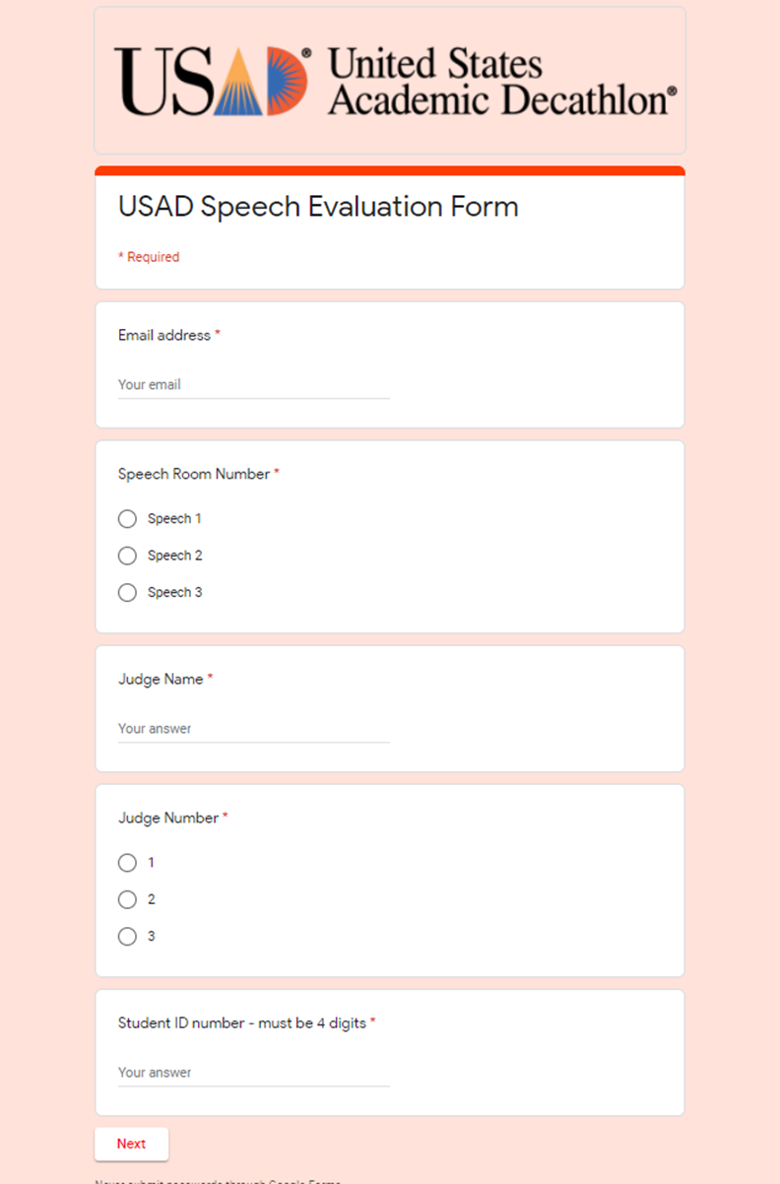

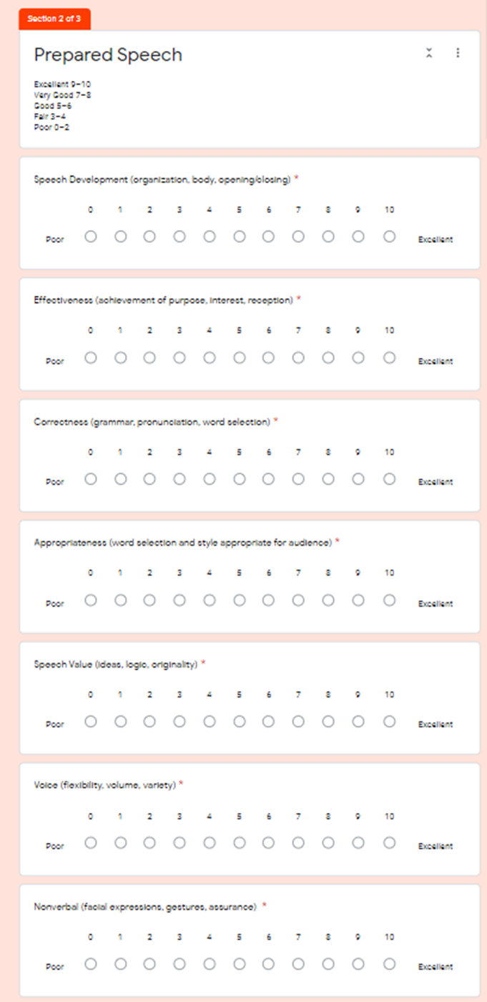

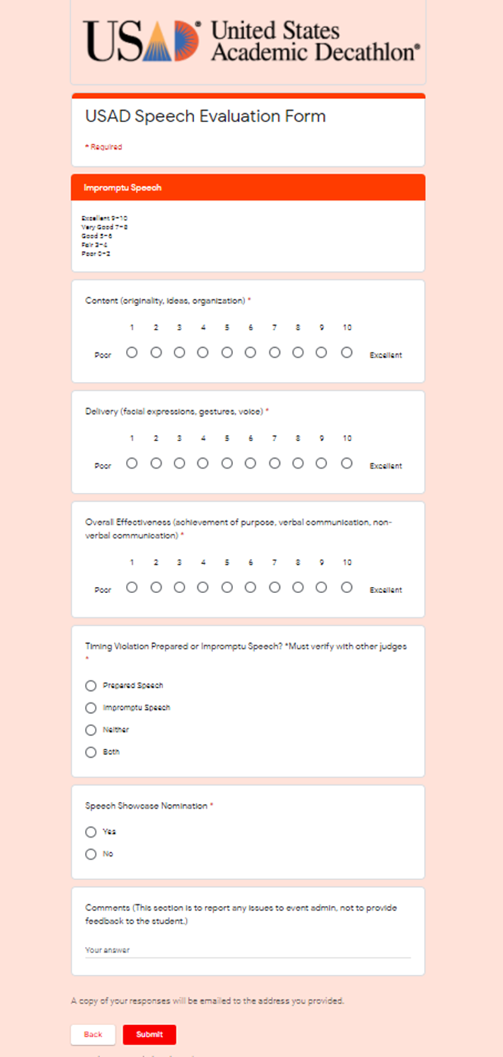

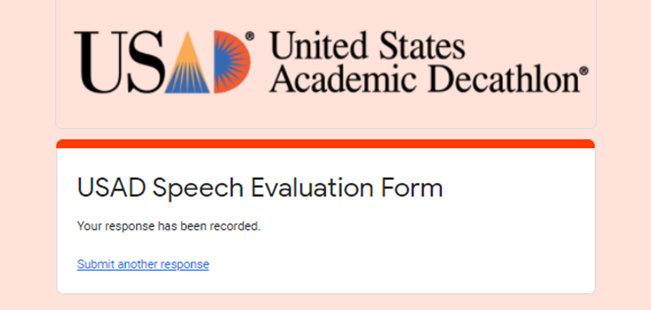

**EVALUATION FORM**

What was your role? ❑ Speech Judge ❑ Head Judge ❑ Timer

|  |  |  |  |
| --- | --- | --- | --- |
| Chart: ➄ = Excellent ➃ = Great ➂ = Average ➁ = Below Average ➀ = Poor | | **Circle one** | **Rating** |
| **Questions / Comments** | |
| 1. | Do you feel you were given adequate training to perform your job? Comments: | **Yes**  **No** | ➄ ➃ ➂ ➁ ➀ |
| 2. | What was the most critical component of the training? |  |  |
| 3. | Was the time allotted sufficient for the training? Comments (suggestions): | **Yes**  **No** | ➄ ➃ ➂ ➁ ➀ |
| 4. | Was the time allotted sufficient for each Decathlete, judging, etc. in the actual session?  Comments (suggestions): | **Yes**  **No** | ➄ ➃ ➂ ➁ ➀ |
| 5. | Would you be willing to judge again in the future? If yes, print name and phone number at the bottom of this evaluation form. Comments: | **Yes**  **No** |  |

***Additional comments can be made on the back of this evaluation form.***

(Optional)

Print Name: Phone w/Area Code:

E-mail:

Please return completed evaluation form to the test collection center at the end of the day.

***Thank you for volunteering!***